***BOOK REVIEW ASSIGNMENT***

TITLE OF THE BOOK: THREE THOUSAND STITCHES

NAME OF THE AUTHOR: SUDHA MURTY

NAME OF THE PUBLICATION: PENGUIN PUBLICATION

YEAR OF PUBLICATION: 2017

REVIEWED BY: KRISHNA VIRADIYA

PRESENTED TO: MS. SNEHA BAJAJ

ENROLLMENT NO.: 22BT04056

SEMESTER: 1st

STREAM: B.TECH-CSE

ACADEMIC YEAR: 2022

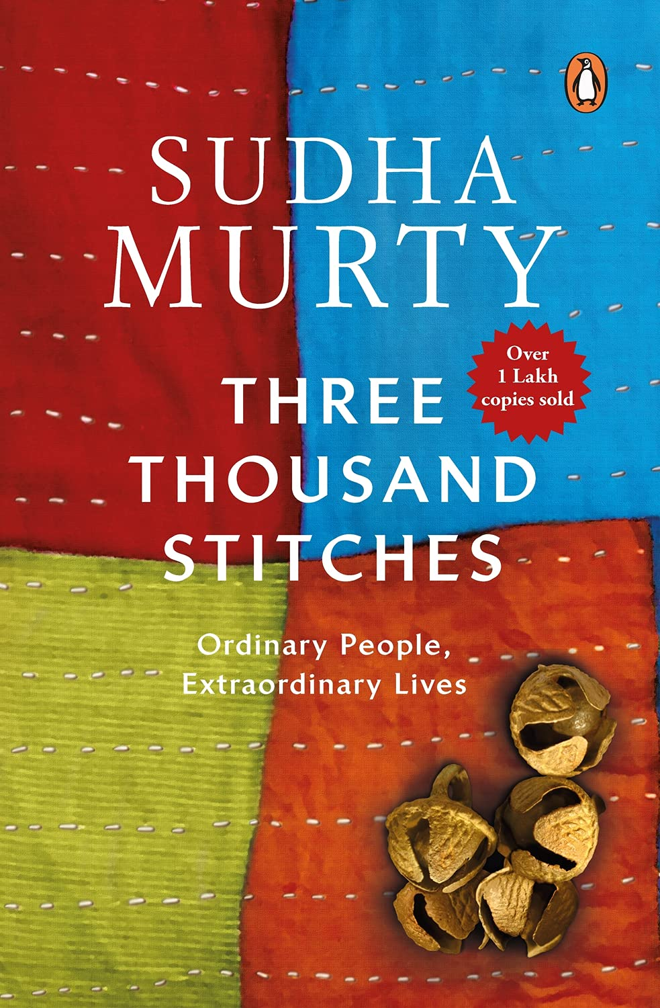

***REASON TO CHOOSE THIS BOOK***

Life of Sudha Murthy has inspired me a lot and her stories works like a motivation for me. The main objective for me to choose this book is, it contains the stories about incidents that happened in her life, people she met and mostly shares her knowledge in a way that the reader can be inspired by it and eventually contribute in making the society even better. Reading a book penned by Smt. Sudha Murty is always an interesting experience. Her stories reflect the real people and that makes it easy for the me to connect with them. Today I am going to share about Three Thousand Stitches: Ordinary People, Extraordinary Lives by Smt. Sudha Murty. Fortunately, I got a chance to read it, and here are my views and reviews about the same. This book is a short story collection. The cover page of this book is expected to reflect some of the elements from those stories. As we can see the cover page shows “stitches” on various cloths and shows some ornaments on it. It represents the theme (stories exploring various themes weaved together) of the book and is attractive as well. Each of the stories in this book explores real-life incidents. And they are written in an interesting manner. Actually, reading such stories let us explore the realities of the society. Such stories make us aware of the positive and negative aspects of the society and inspire us to make it better. I really like this book and so I would highly recommend reading this book to all the readers by writing an honest review on it.

***ABOUT THE AUTHOR***

Sudha Murty was born into a Kannada Deshastha Madhva Brahmin family on 19 August 1951 in Shiggaon, Haveri in Karnataka, India, the daughter of R. H. Kulkarni, a surgeon, and his wife Vimala Kulkarni, a school teacher. She was raised by her parents and maternal grandparents. These childhood experiences form the historical basis for her first notable work entitled How I Taught My Grandmother to Read, Wise and Otherwise and Other Stories.

She completed a B.Eng. in Electrical and Electronics Engineering from the B.V.B. College of Engineering & Technology (now known as KLE Technological University), and then a M.Eng. in Computer Science from the Indian Institute of Science. Sudha Murty became the first female engineer hired at India's largest auto manufacturer TATA Engineering and Locomotive Company (TELCO). She joined the company as a Development Engineer in Pune and then worked in Mumbai & Jamshedpur as well. She had written a postcard to the company's Chairman complaining of the "men only" gender bias at TELCO. As a result, she was granted a special interview and hired immediately. She later joined Walchand Group of Industries at Pune as Senior Systems Analyst.

In 1996, she started Infosys Foundation and to date has been the Trustee of Infosys Foundation and a Visiting Professor at the PG Centre of Bangalore University. She also taught at Christ University.

Sudha Murty has written and published many books which include novels, non-fiction, travelogues, technical books, and memoirs. Her books have been translated into all major Indian languages. She is also a columnist for English and Kannada newspapers.

Her work is emotional, truthful and so real, that the reader is touched and can feel the aura of the story around. Every author has a story behind writing a book which Sudha also has, but the only difference is, her behind the story is so realistic that creates an interest in readers to read the book.

***ABOUT THE BOOK***

The name of Mrs. Sudha Murthy, co-founder of the world-renowned company Infosys and multi-eminent author, does not need any introduction.

She is Kannada speaking and writing in Kannada is more comfortable for her than in English. But Mr. T.J.S. taking inspiration from George, she started writing in English. She has also dedicated this book to Mr. George.

Sudha ji's life experiences and deep feelings can be seen in "teen thousand stitches".

In this book, she has described eleven such incidents related to her life, which encourage man to move forward by taking him out of the whirlpool of despair.

With the establishment of the Infosys foundation in 1996, Sudha ji first decided to work for the revival of the devadasi system by abolishing it.

She met the devadasis, understood their pitiable condition, understood their needs and arranged many facilities for them. In this way, facing many difficulties, with tireless hard work and courage, she succeeded in reviving three thousand devadasis and their families.

Sudha ji was born in a conservative family. So when she decided to be an engineer, she faced opposition from her family. But determined Sudha ji remained firm and took admission in the engineering college. And despite being the only female student facing many problems, she passed this exam with the best marks.

She proved that women can also prove their superiority by defeating men in every field of life.

In food for thought, Sudha ji describes the knowledge she received from her friend's botanist father about fruits and vegetables that we think are Indian, but are actually foreign.

Memories related to Banaras lord Vishwanath and Patit-Pavani ganga and depiction of the faith of South Indians can be seen in "Trianjali Neer". Sudha ji visited Banaras in February 1996 and has shared her experiences related to that visit in this section.

“The Cattle Class” reflects Sudha ji's experiences about a special class who live a double life of appearances.

Sudha ji's father was a doctor. He was a kind hearted person and in his life, he helped many people in every possible way while fighting against adverse circumstances. Readers get to read many poignant incidents depicting the father's goodwill in 'an unwritten life'.

Sometimes poverty creates such situations that a person leaves his home and family and goes abroad to earn money. After reaching there, he gets entangled in what vicious circles, how many injustices and atrocities he suffers and how he yearns to return home. The story of some such women is shown in 'no place like home'.

The popularity of Indian actors and actresses and their films abroad is not hidden from anyone. Sudha ji has given them the name of Indian ambassador because they are the carrier of our culture and art in the whole world.

The descriptions in this book are very interesting in which Sudha ji narrates mythological stories to her grandchildren living abroad and of them the children create new stories by connecting them with the modern environment.

We also get to see the glimpse of Sudha ji's busiest routine in this book. She did many commendable works in the direction of awakening social consciousness.

She met many people who had lost their money-property, wife-children and relatives-relatives in the 'aye aye' group. This is a group that works in the field of de-addiction.

In summary, this book is based on various incidents, problems and experiences and presents the true picture of our society in front of us.

In this, there is a Devdas society suffering social exploitation, then there is a section fighting economic problems, which runs away to foreign countries and finally it is known that it is only a mirage.

Each incident described in the book gives us the message of struggle instead of running away and encourages us to fight against adverse circumstances.

This book by Sudha Murthy is basically in English and it has been translated to many other languages without disturbing the soul of the book which makes it interesting to read in any language you are comfortable with.

From the point of view of language, it has used practical wordings which can be easily understood. Tightness is a distinctive quality of language and it is visible throughout this book.

“Three Thousand Stitches” – this book is not a novel or a collection of stories, but it is a compilation of such incidents related to the life of Sudha Murthy, which can be called a form of memoir.

Each incident is different so the characters are also different. But the biggest feature of the characters is that they are simple and straightforward and appear to be telling their own sad stories.

Each incident of this book begins very simply, has many twists and turns and many difficulties and gradually they reach their climax.

There are total eleven chapters in this book and Sudha ji has given different titles to each chapter. As events progress, the usefulness and significance of these titles begin to be proved.

The stories are mostly warm and simple; and in turn, trigger slivers of thought as she broaches the issues of alcoholism, conservatism, exploitation and discrimination. From being a little girl to being a grandmother, from being a naivete to a professional achiever, she chronicles her trials and travails, and offers advice, sometimes way too bluntly and sometimes, in garbs of conversation. One is likely to learn something new, like the origin of indigenous vegetables, and frown at her firm assumptions, especially in relation to long-standing traditions and religious tenets. The writing, though, aids the reading and the unvarnished prose tempted me to finish this book in one go. A good read, with plenty to chew and some humour can help us to ease the occasional tension.

***MORAL OF THE BOOK***

The stories have an overarching theme of empathy and service to the society. This book can help us to understand the society and ourselves from all the possible directions. It conveys message that “Because one believes in oneself, one doesn't try to convince others. Because one is content with oneself, one doesn't need others' approval. Because one accepts oneself, the whole world accepts him or her.”

***WHAT IS YOUR TAKE AWAY?***

* *WHAT DID YOU FEEL WHILE READING/DURING THE PROCESS OF READING?*

Each of these stories explores real-life incidents. And they are written in an interesting manner. Actually, reading such stories let us explore the realities of the society.

* *WHAT DID YOU FEEL AFTER THE COMPLETION?*

Stories from this book allow us to feel connected with others and part of something bigger than ourselves. Reading this book can provide an escape from boredom or stress and help us to better understand and interact with other people and teaches us how to grow as individuals.

* *WHAT ARE YOUR IMPRESSIONS ABOUT THE AUTHOR?*

Sudha Murthy's noble beliefs are reflected in her stories by her active participation in social work for art and culture, public hygiene, healthcare, poverty alleviation, and women empowerment and education. She is a women with a large heart and for me she is the one who deserves lots of respect for these.

* *WHAT DID YOU LIKE THE MOST ABOUT THE BOOK?*

A story revealing the author’s love for movies was the part I liked the most. She loves watching movies and talks about how movies also connect people from various caste, creed and countries. So, basically she was trying to influence the culture of our country all around the world and unite all the nations. This respect for culture and humanity in her heart is something that touched my inner core.

* *GIVEN A CHOICE WHAT WOULD YOU LIKE TO CHANGE ABOUT THIS BOOK?*

This book is written very well by the author and everything in it seems to be perfect. It can be made look more better if we add some pictures or cartoons in it which can make it more interesting to read.

* *HOW DOES THE BOOK IMPACTED TO YOUR LIFE?*

This book teaches us about myriad of human relations and the emotions that are bound to them. It also teaches us about the deep commitments to achieve goals and prove her mettle at various stages of her life as a young girl, as a college student, and as a chairperson of the Infosys Foundation.

* *HOW CAN THIS BOOK INFLUENCE THE SOCIETY OR CAN BE USEFUL FOR THE SOCIETY?*

Such stories make us aware of the positive and negative aspects of the society and inspire us to make it better. I would highly recommend reading this book to all the readers.